[[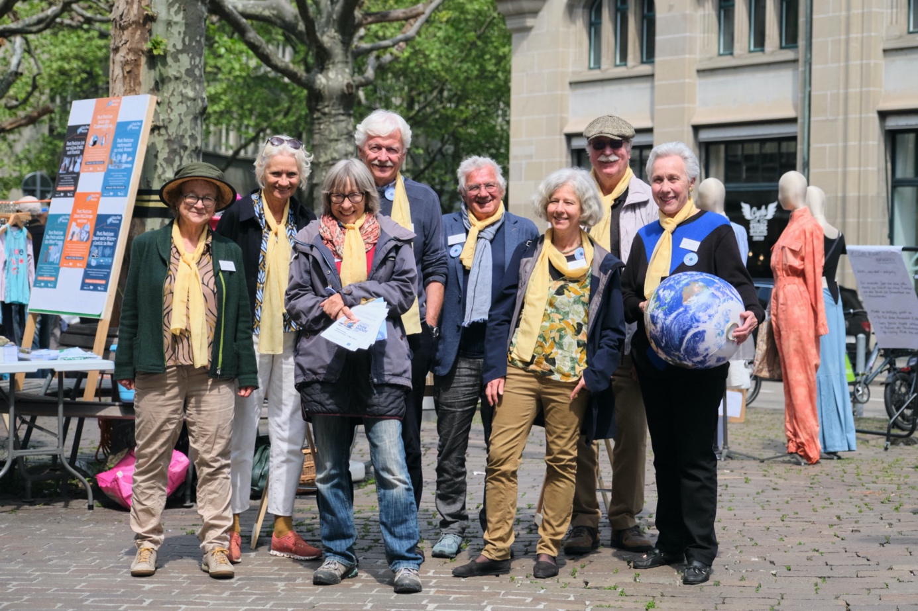](https://ad52e6bc24.clvaw-cdnwnd.com/923582a270787277a8f5437a9f30fa6f/200000602-5522155222/003_Kleidertausch_NEU.jpg?ph=ad52e6bc24)](https://ad52e6bc24.clvaw-cdnwnd.com/923582a270787277a8f5437a9f30fa6f/200000602-5522155222/003_Kleidertausch_NEU.jpg?ph=ad52e6bc24)

[[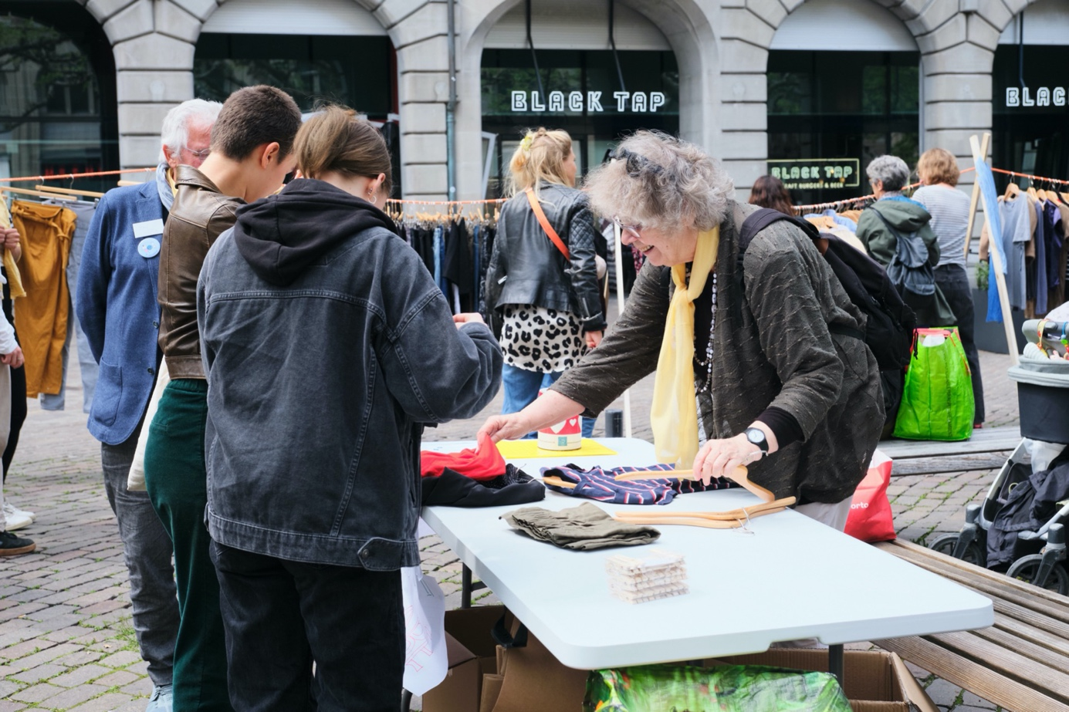](https://ad52e6bc24.clvaw-cdnwnd.com/923582a270787277a8f5437a9f30fa6f/200000603-52edd52edf/013_Kleidertausch.jpg?ph=ad52e6bc24)](https://ad52e6bc24.clvaw-cdnwnd.com/923582a270787277a8f5437a9f30fa6f/200000603-52edd52edf/013_Kleidertausch.jpg?ph=ad52e6bc24)

[[Ein Bild, das Boden, draußen enthält.
](https://ad52e6bc24.clvaw-cdnwnd.com/923582a270787277a8f5437a9f30fa6f/200000604-6755f67561/017_Kleidertausch.jpg?ph=ad52e6bc24)](https://ad52e6bc24.clvaw-cdnwnd.com/923582a270787277a8f5437a9f30fa6f/200000604-6755f67561/017_Kleidertausch.jpg?ph=ad52e6bc24)

[[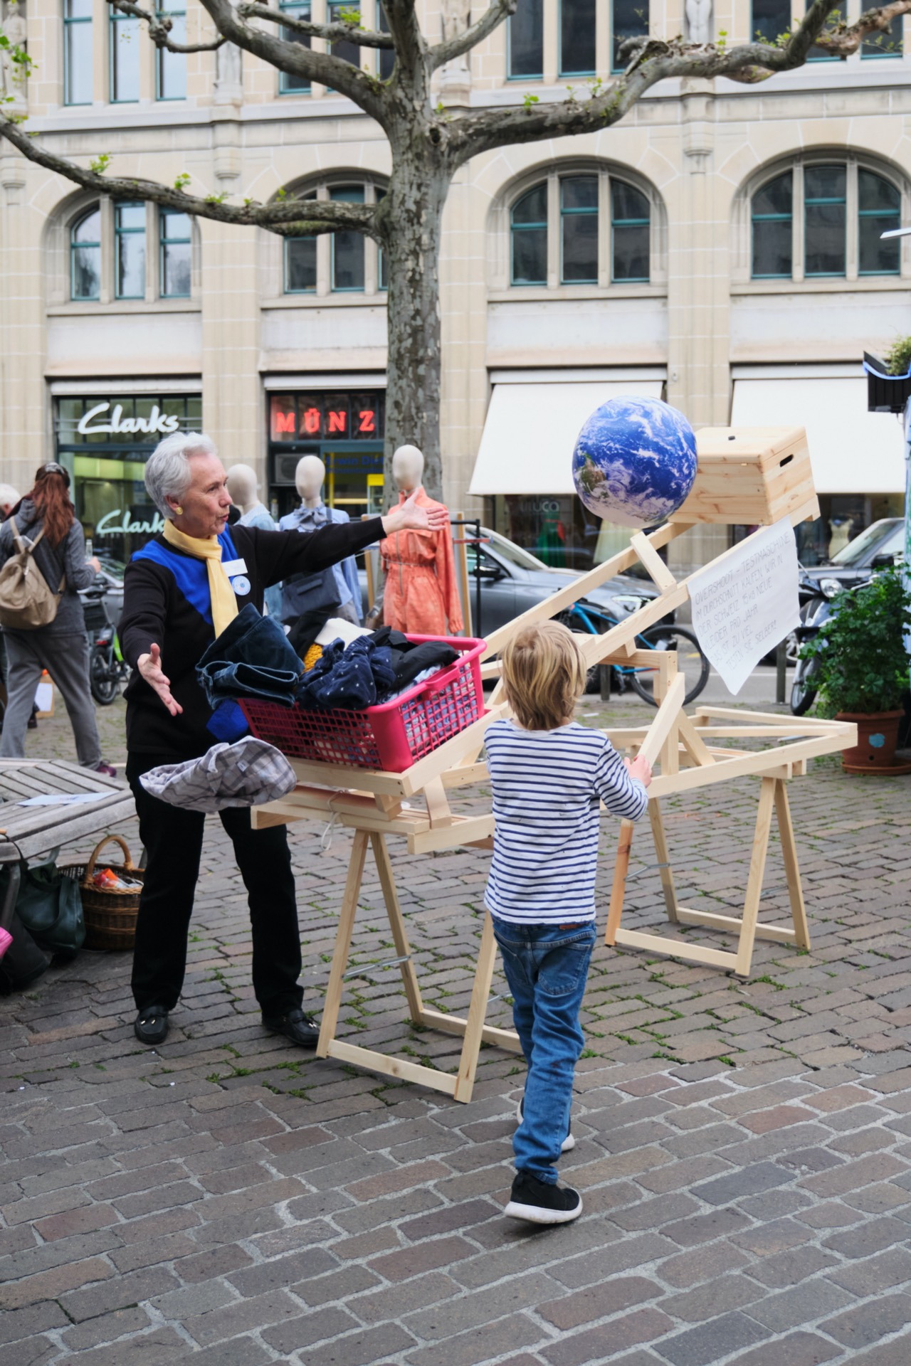](https://ad52e6bc24.clvaw-cdnwnd.com/923582a270787277a8f5437a9f30fa6f/200000605-3d7113d714/023_Kleidertausch.jpg?ph=ad52e6bc24)](https://ad52e6bc24.clvaw-cdnwnd.com/923582a270787277a8f5437a9f30fa6f/200000605-3d7113d714/023_Kleidertausch.jpg?ph=ad52e6bc24)

[[Ein Bild, das draußen, Baum, Boden, Personen enthält.
](https://ad52e6bc24.clvaw-cdnwnd.com/923582a270787277a8f5437a9f30fa6f/200000606-5e2765e278/033_Kleidertausch.jpg?ph=ad52e6bc24)](https://ad52e6bc24.clvaw-cdnwnd.com/923582a270787277a8f5437a9f30fa6f/200000606-5e2765e278/033_Kleidertausch.jpg?ph=ad52e6bc24)

[[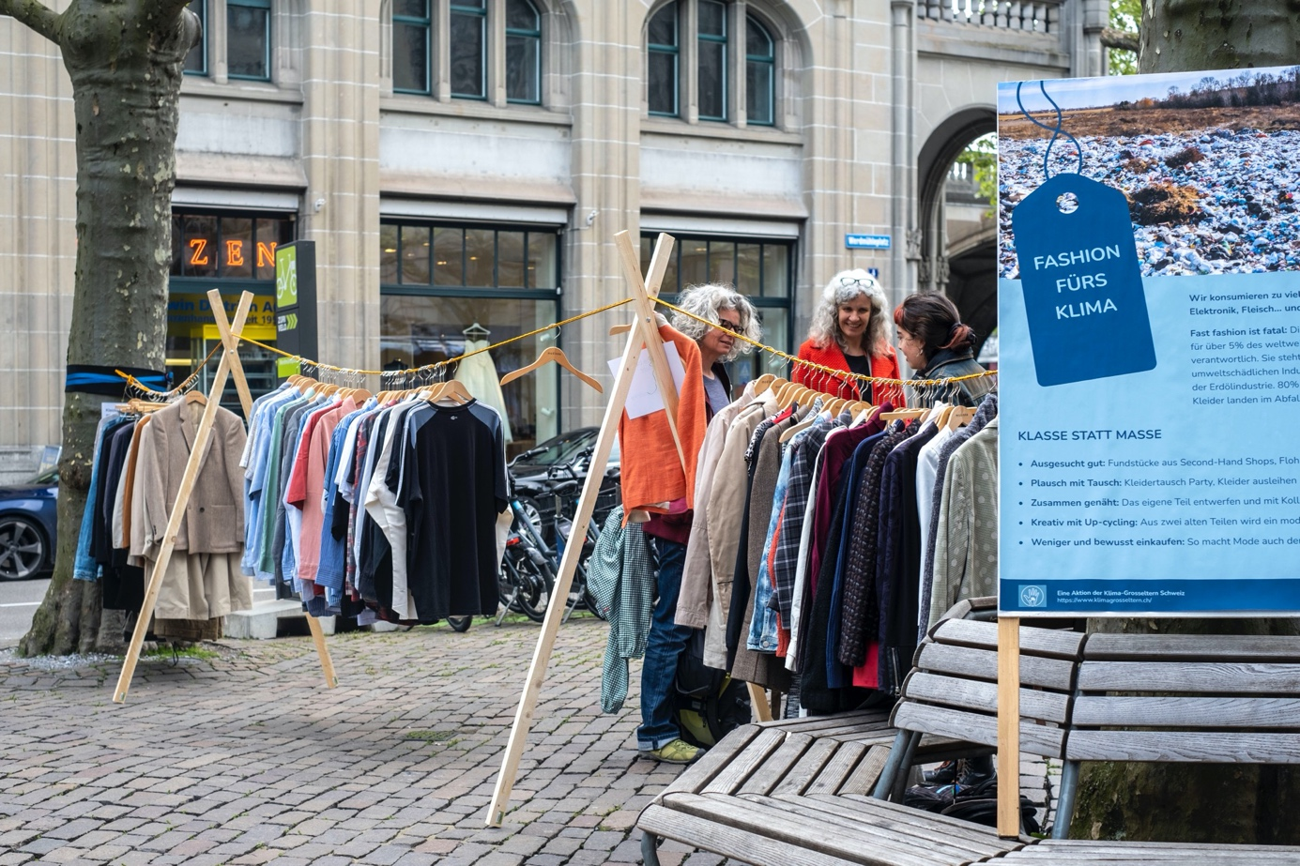](https://ad52e6bc24.clvaw-cdnwnd.com/923582a270787277a8f5437a9f30fa6f/200000607-6477664779/ec_klimagrosseltern_0241.JPG?ph=ad52e6bc24)](https://ad52e6bc24.clvaw-cdnwnd.com/923582a270787277a8f5437a9f30fa6f/200000607-6477664779/ec_klimagrosseltern_0241.JPG?ph=ad52e6bc24)

[[Ein Bild, das Baum, draußen, Personen enthält.
](https://ad52e6bc24.clvaw-cdnwnd.com/923582a270787277a8f5437a9f30fa6f/200000608-50a1e50a20/ec_klimagrosseltern_0242.JPG?ph=ad52e6bc24)](https://ad52e6bc24.clvaw-cdnwnd.com/923582a270787277a8f5437a9f30fa6f/200000608-50a1e50a20/ec_klimagrosseltern_0242.JPG?ph=ad52e6bc24)

[[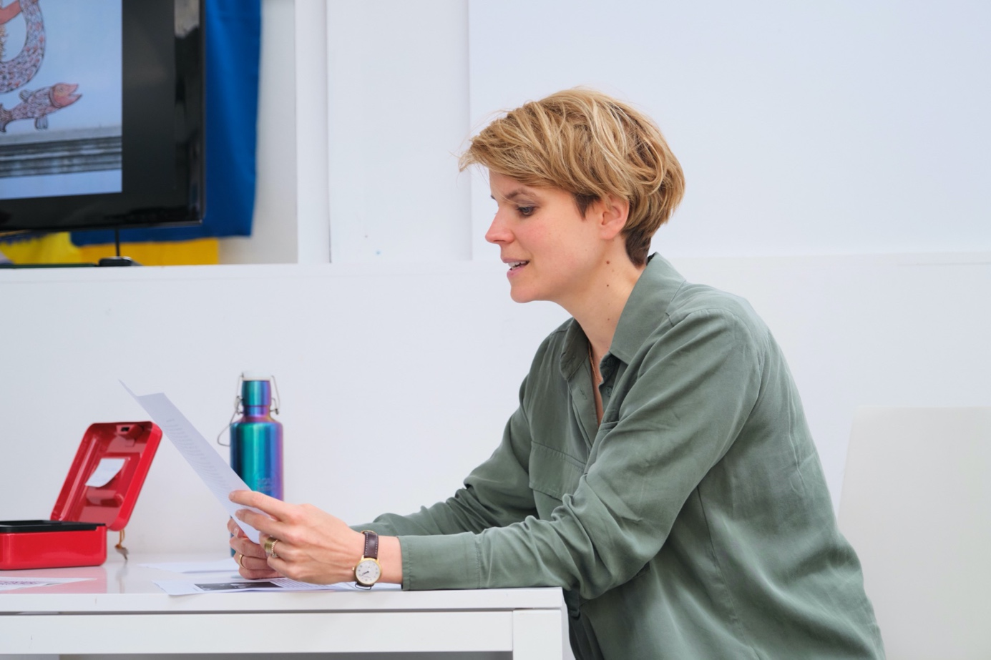](https://ad52e6bc24.clvaw-cdnwnd.com/923582a270787277a8f5437a9f30fa6f/200000601-b04e2b04e5/001_Kleidertausch.jpg?ph=ad52e6bc24)](https://ad52e6bc24.clvaw-cdnwnd.com/923582a270787277a8f5437a9f30fa6f/200000601-b04e2b04e5/001_Kleidertausch.jpg?ph=ad52e6bc24)

Fotos: Peter Reutlinger und Ela Çelik (Tages-Anzeiger, Foto No. 1 und 2)